***PAYMENT BILLING PRODUCT SYSTEM***

***USER MANUAL***

***The PAYMENT BILLING PRODUCT SYSTEM is a web application, can be used for institutions like school,college to manage the accountant records,students records,payments and queries by students,fee details and search particular details about accountant and students.***

***PAGES :***

* ***Login Page.***
* ***Admin.***
* ***Admin Home page.***
* ***New registration page.***
* ***Modify details page.***
* ***Notice page.***
* ***Query page.***
* ***Change password page.***
* ***Accountant.***
* ***Accountant Home page.***
* ***New registration page.***
* ***Modify details page.***
* ***Payment log page.***
* ***Change password page.***
* ***Contact us page.***
* ***Student.***
* ***Detail page.***
* ***Payment page.***
* ***Query page.***
* ***Payment log page.***
* ***Change password page.***
* ***Contact us page.***

***LOGIN PAGE :***

***You can login into the system in three different roles,***

* ***As administrator***
* ***As accountant***
* ***As a student.***

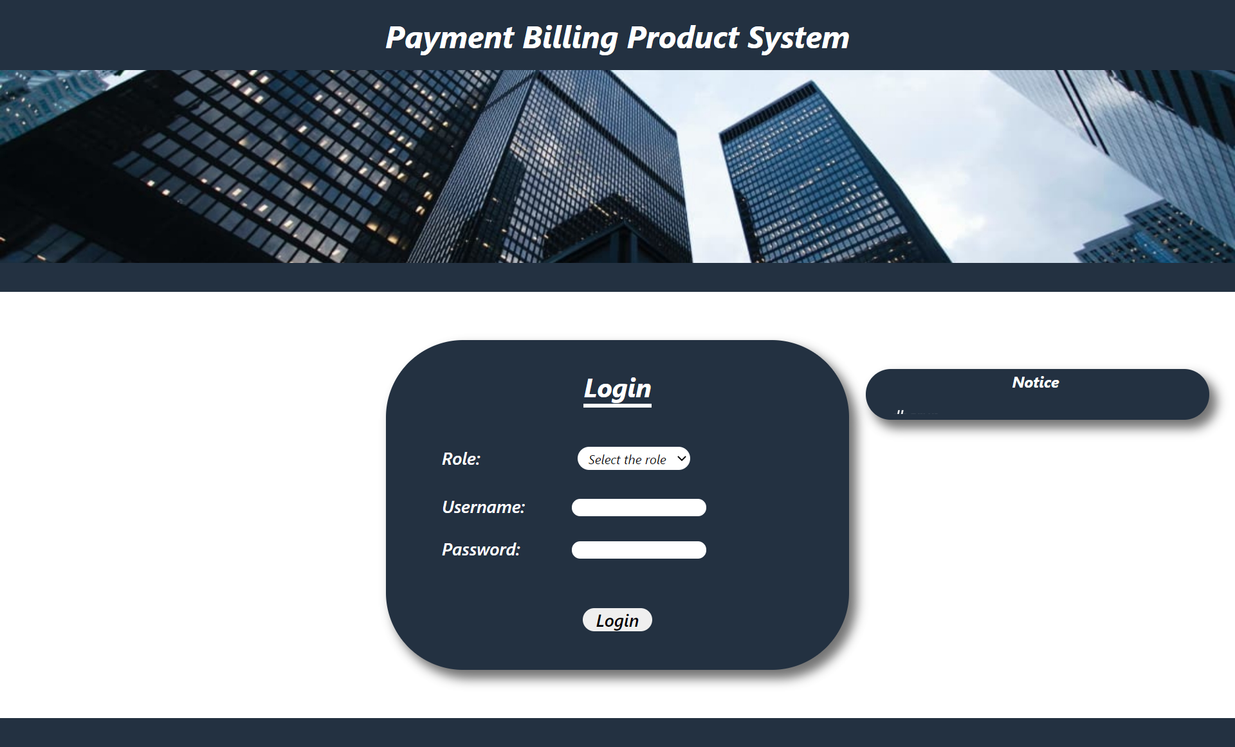

***You can login according to your role,username and password.If you are an accountant your username and password will be given by admin, and if you are a student the username and password will be given by the accountant.***

***ADMIN:***

***1.Admin home page :***

***After you logged in as admin,you will be directed to the admin home page.In this page admin can find and view the details of any accountant.***

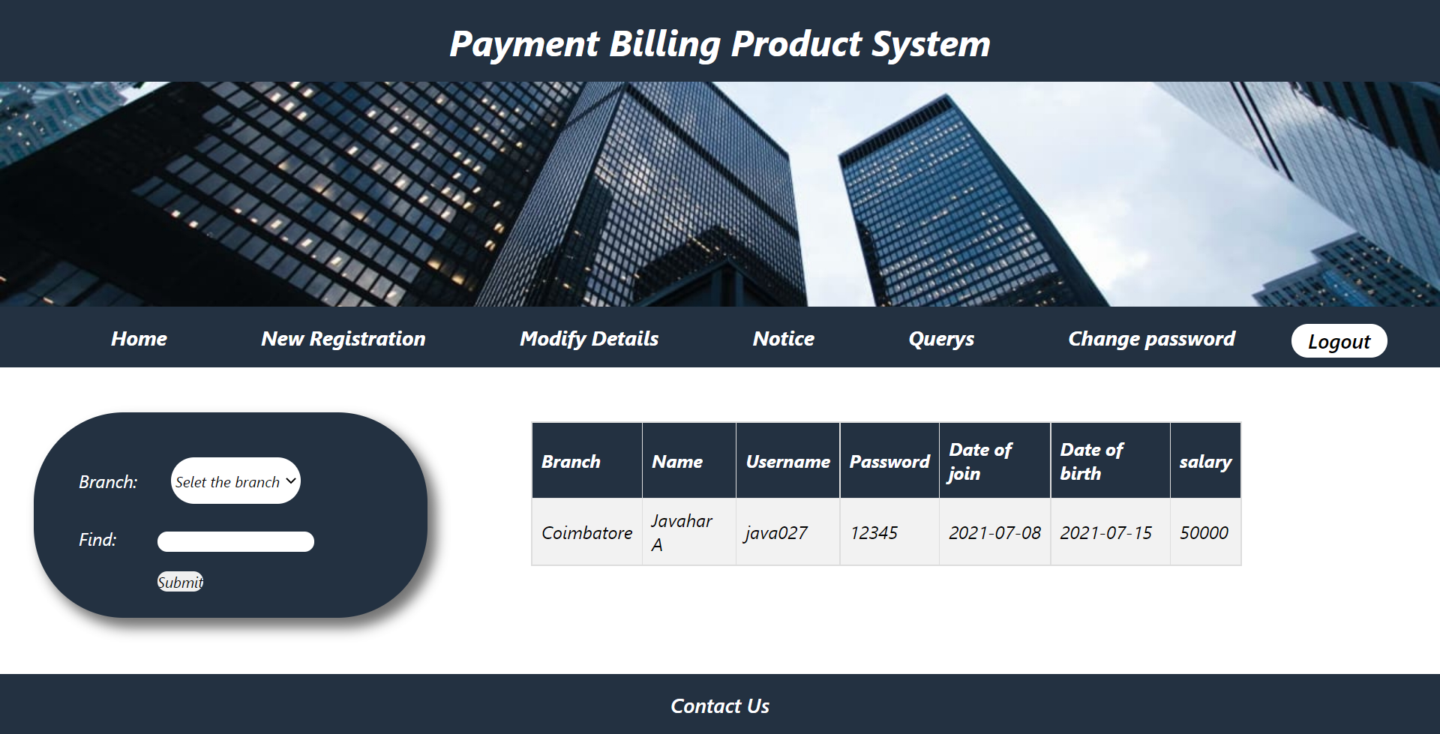

***2.New registration page :***

***In this page admin can add an accountant by filling the details like,branch,name,username,password,date of joining,date of birth and***

***salary.***

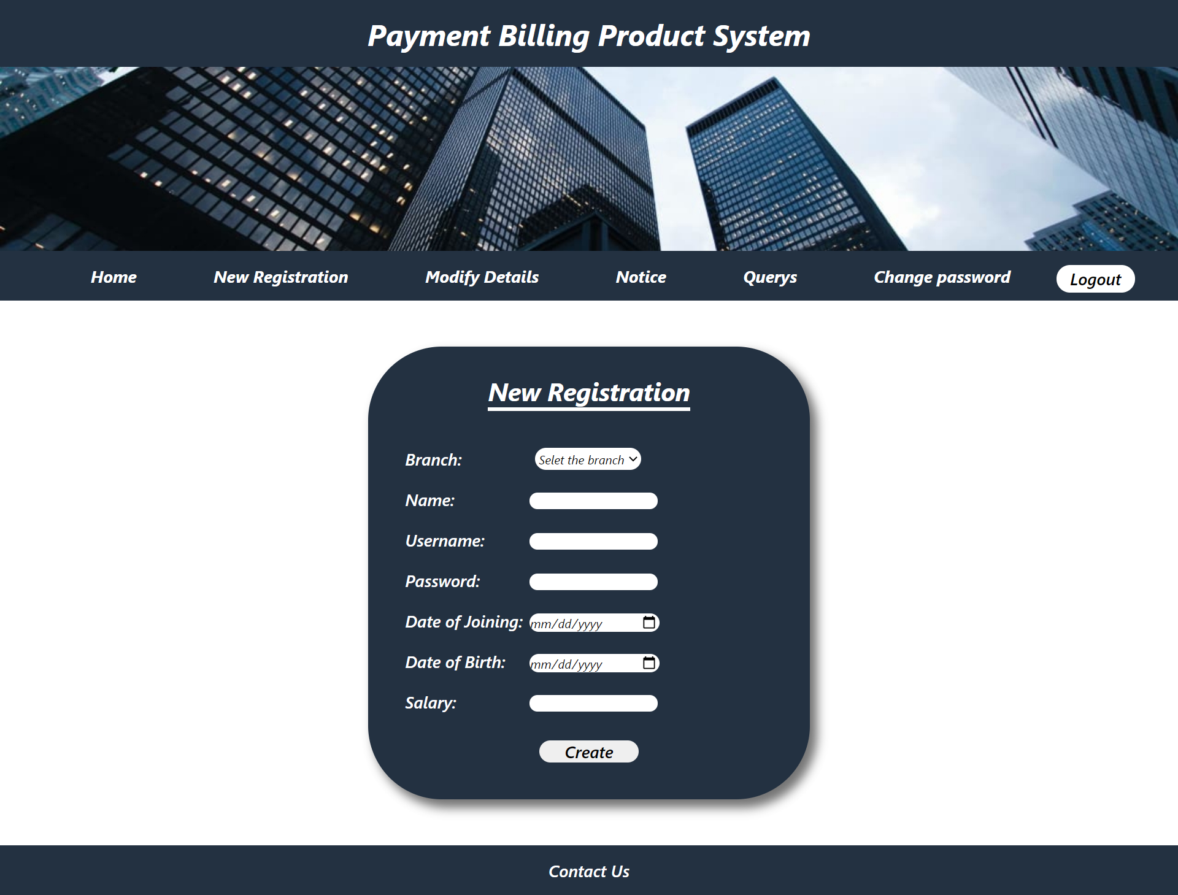

***3.Modify details page :***

***In this page admin can search an accountant and update any details and delete an accountant.If you want to modify select modify in drop down box or else select delete to delete an accountant.***

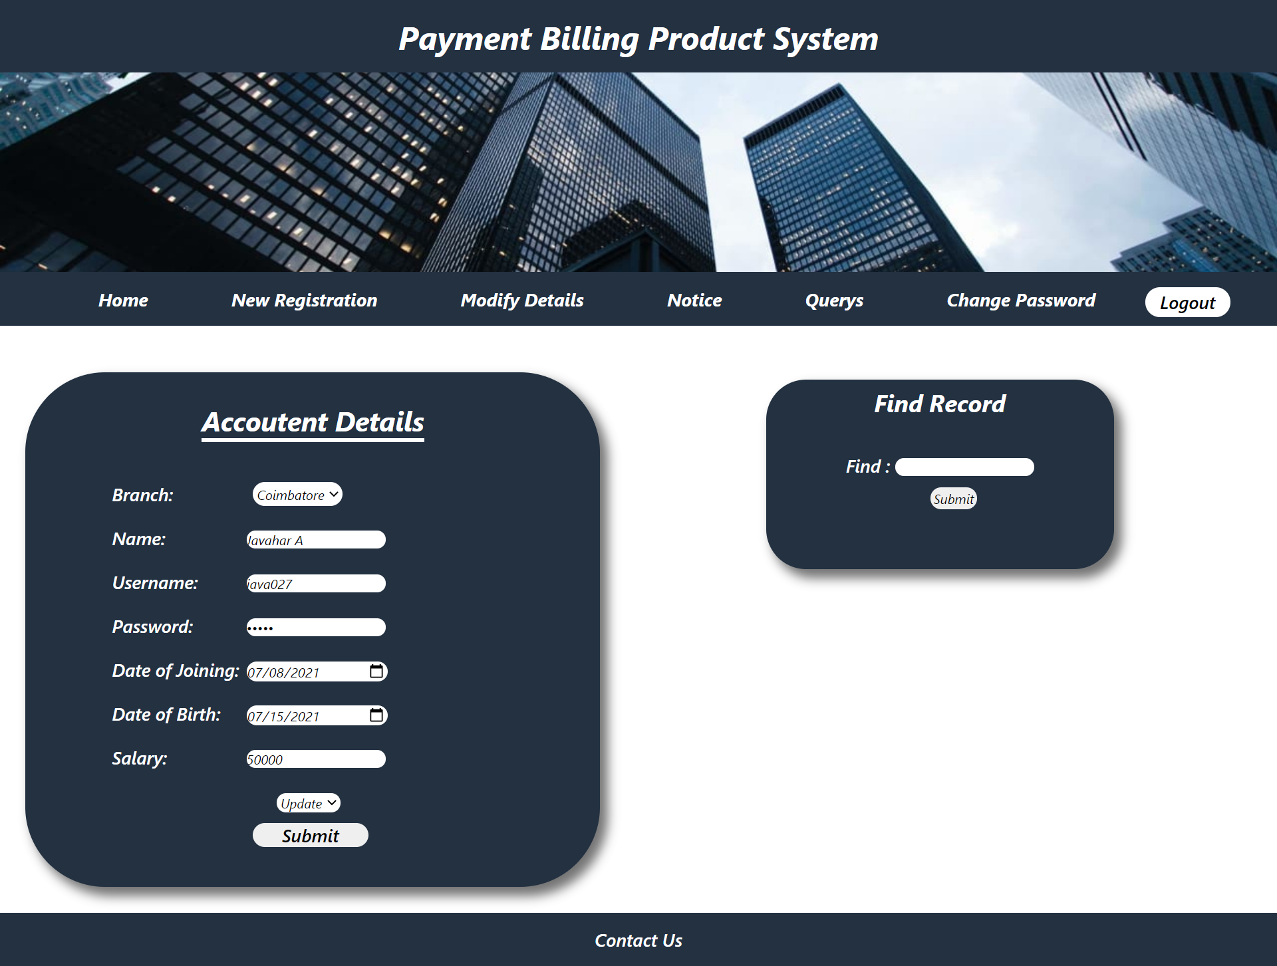

***4.Notice page :***

***In this page admin can add any important note and that will be displayed in the notice board placed in login page so that student can get information up to date.***

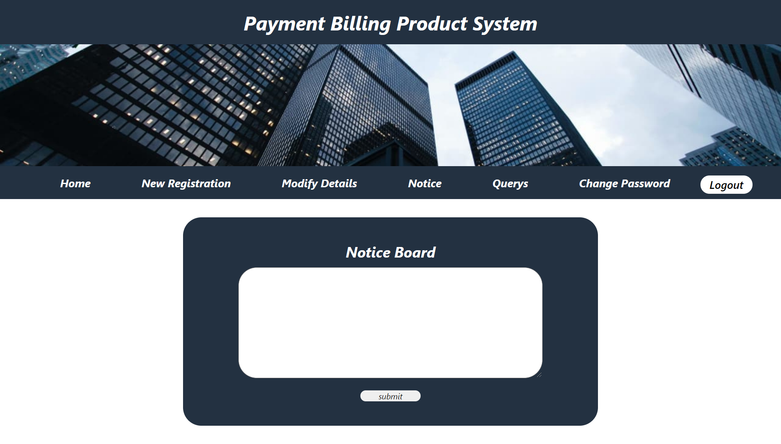

***5.Query Page :***

***In this page,admin can view and mark complete the queries which were posted by students, after completing them.***

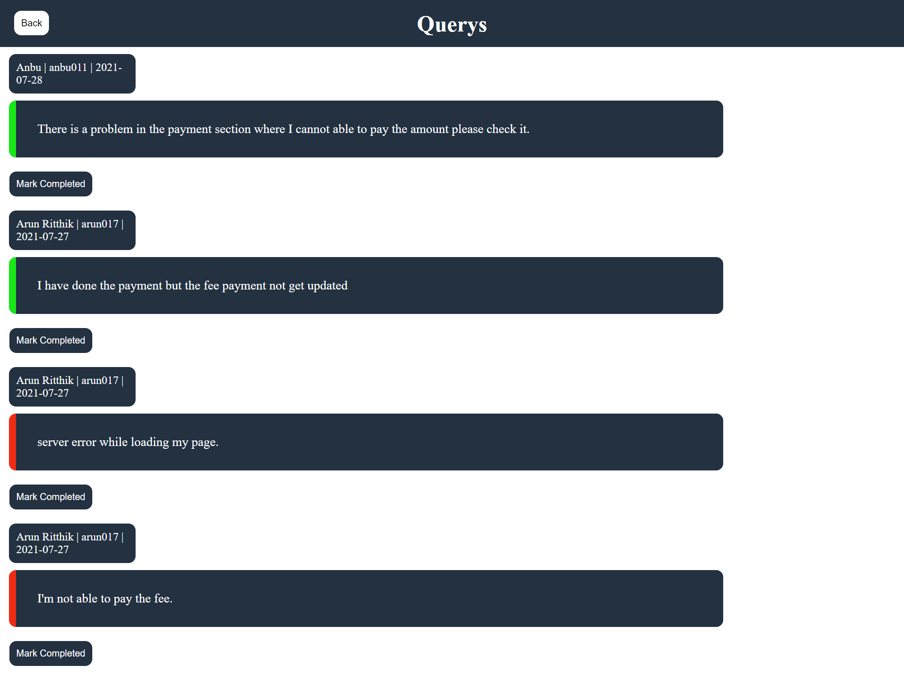

***6.Change Password page :***

***In this page admin can change his/her password if he/she feels insecure.***

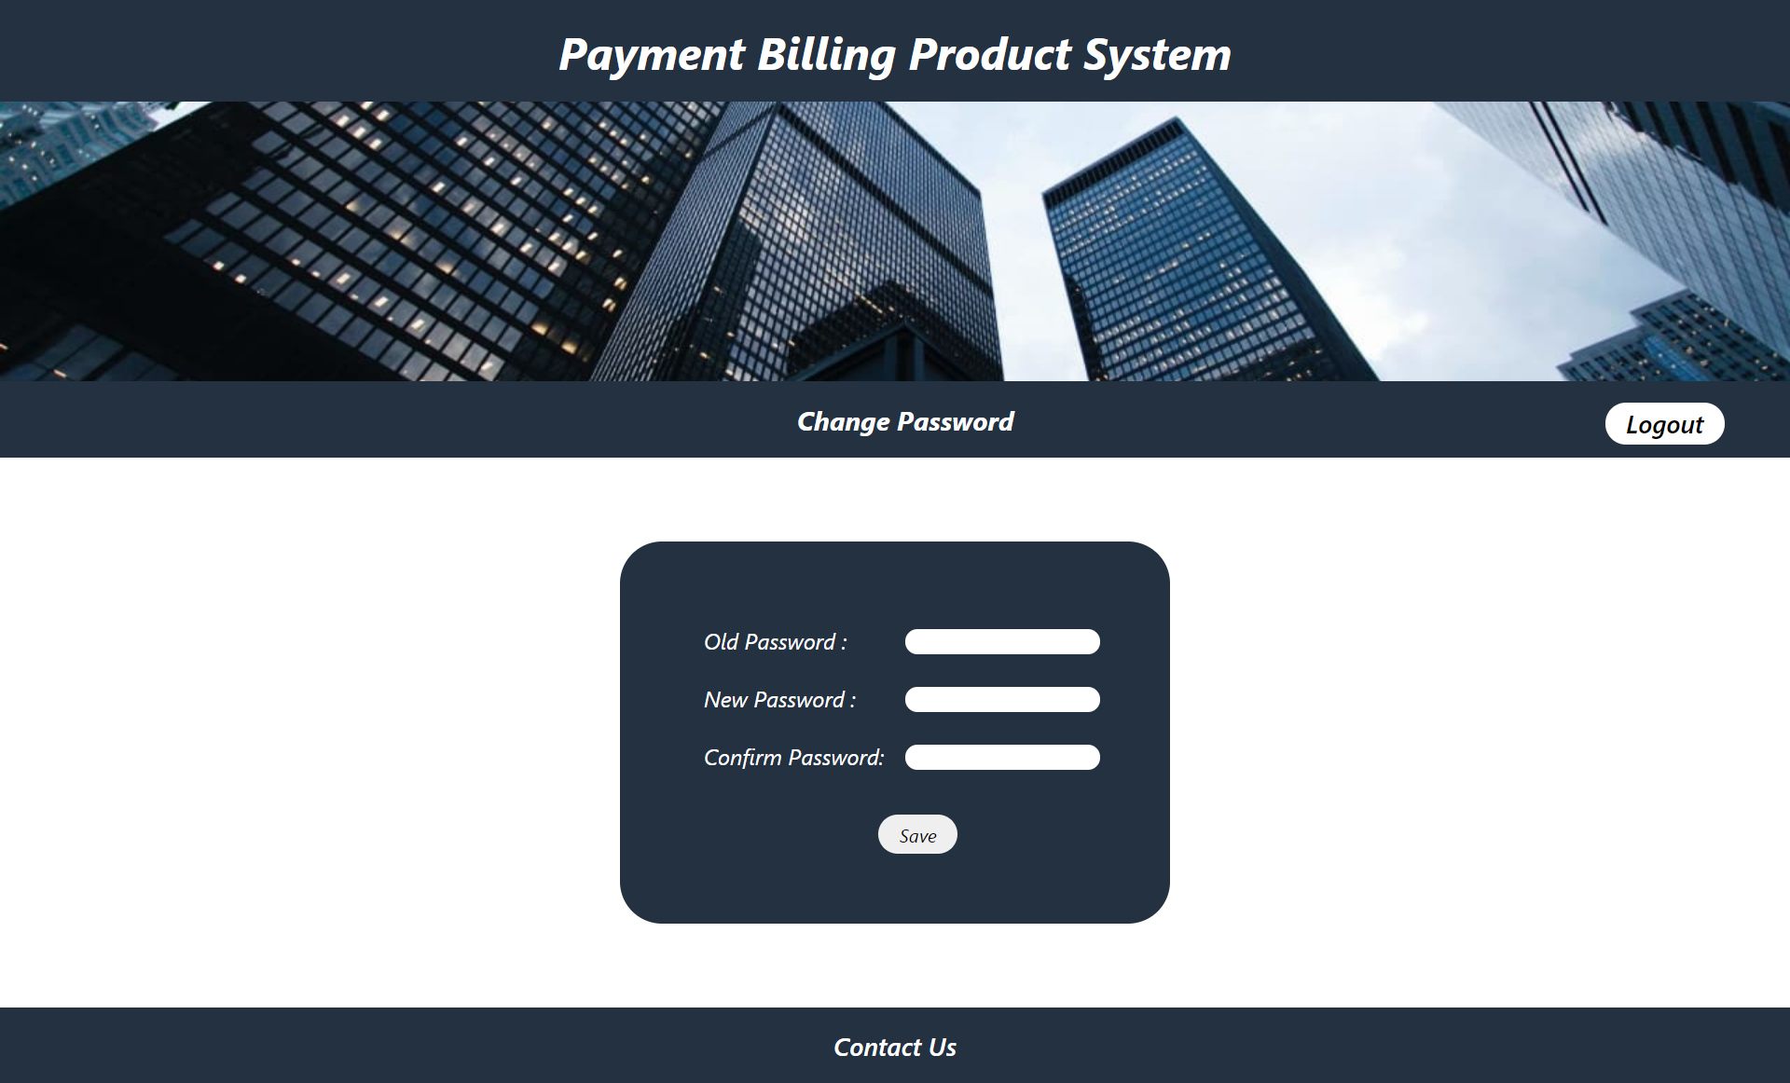

***ACCOUNTANT :***

***1.Accountant home page :***

***After you log in as accountant,you will be directed to the accountant home page.In this page the accountant can find and view the details of any students.***

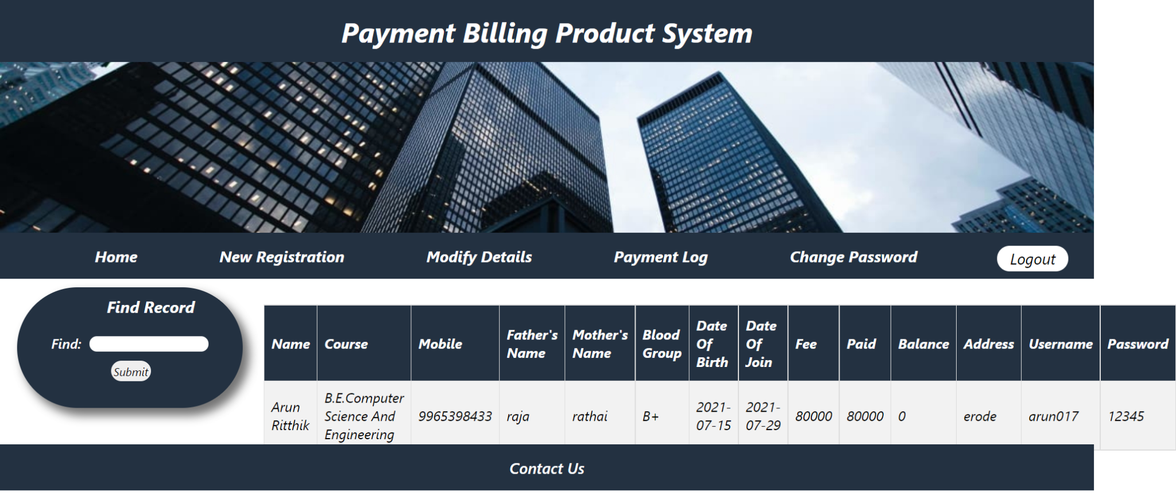

***2.New Registration page :***

***In this page admin can add an accountant by filling in the details like,name,course,mobile,Father’s name,Mother’s name,Blood group,Date of birth,Date of join,Fee,Paid,Balance,Address,Useranme,Password.***

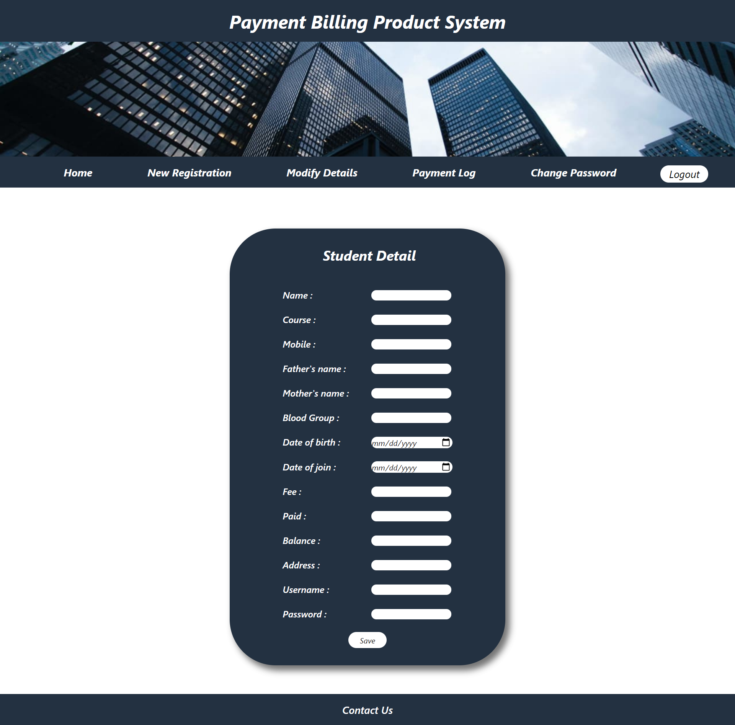

***3.Modify Details page :***

***In this page admin can search a student and update any details and delete a student.If you want to modify select modify in drop down box or else select delete to delete a student.***

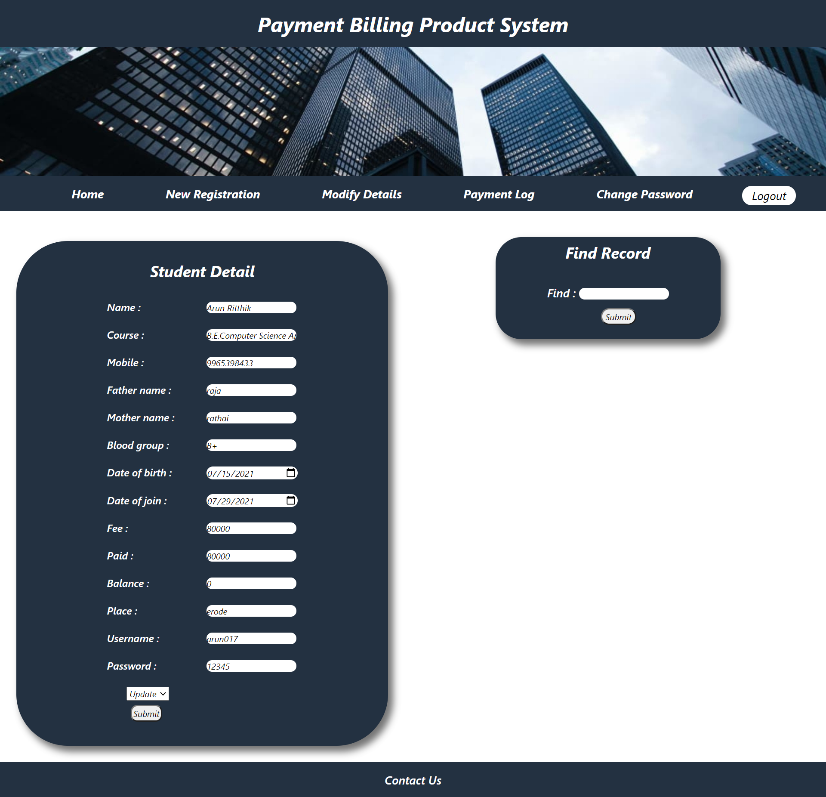

***4.Payment Log page:***

***In this page the accountant can view the payment details of students.Accountant can search by student’s username or the payment date.***

***SEARCH BY USERNAME***

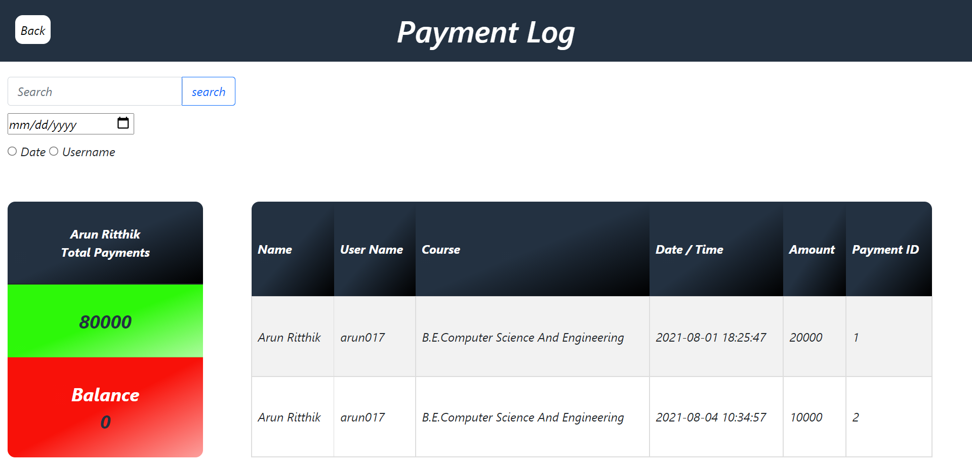

***SEARCH BY DATE***

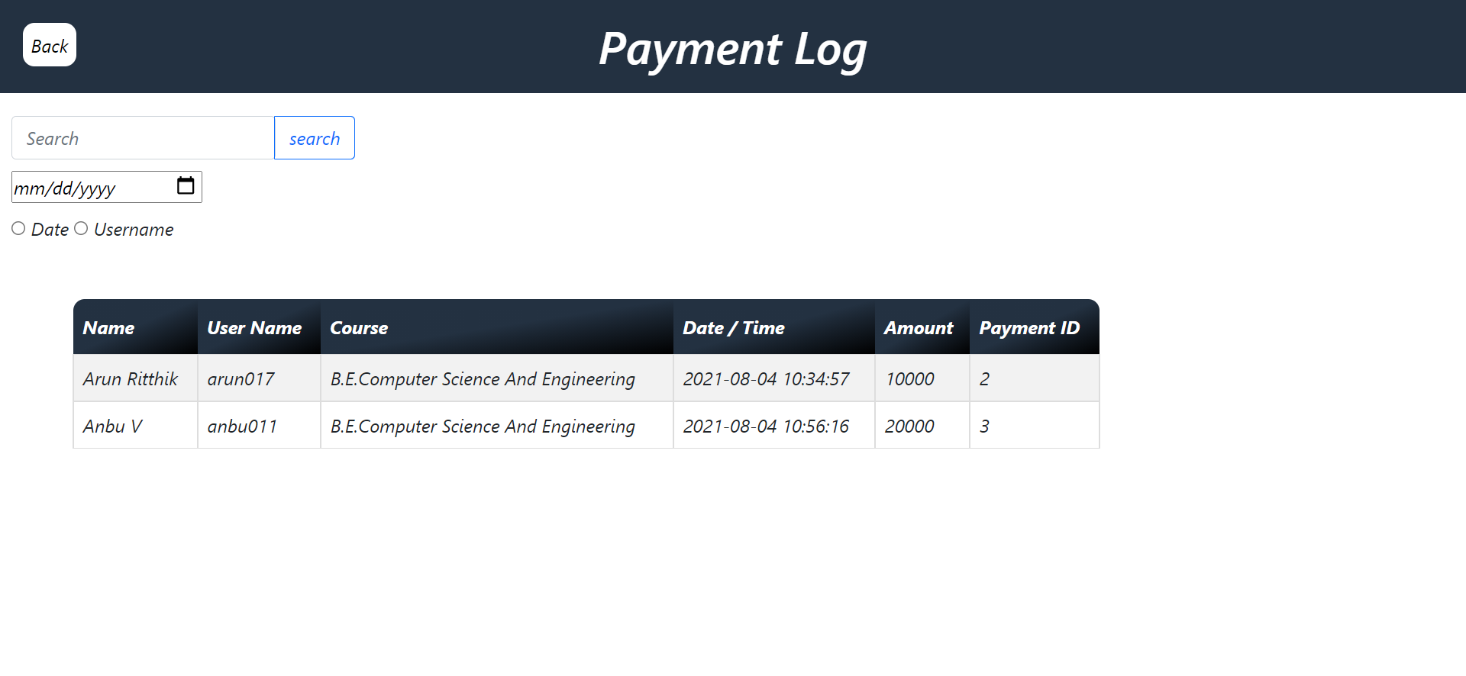

***5.Change Password page:***

***In this page an accountant can change his/her password if he/she feels insecure.***



***STUDENT :***

***1.Detail page :***

***In this page the students can view their personal details and fees details.***

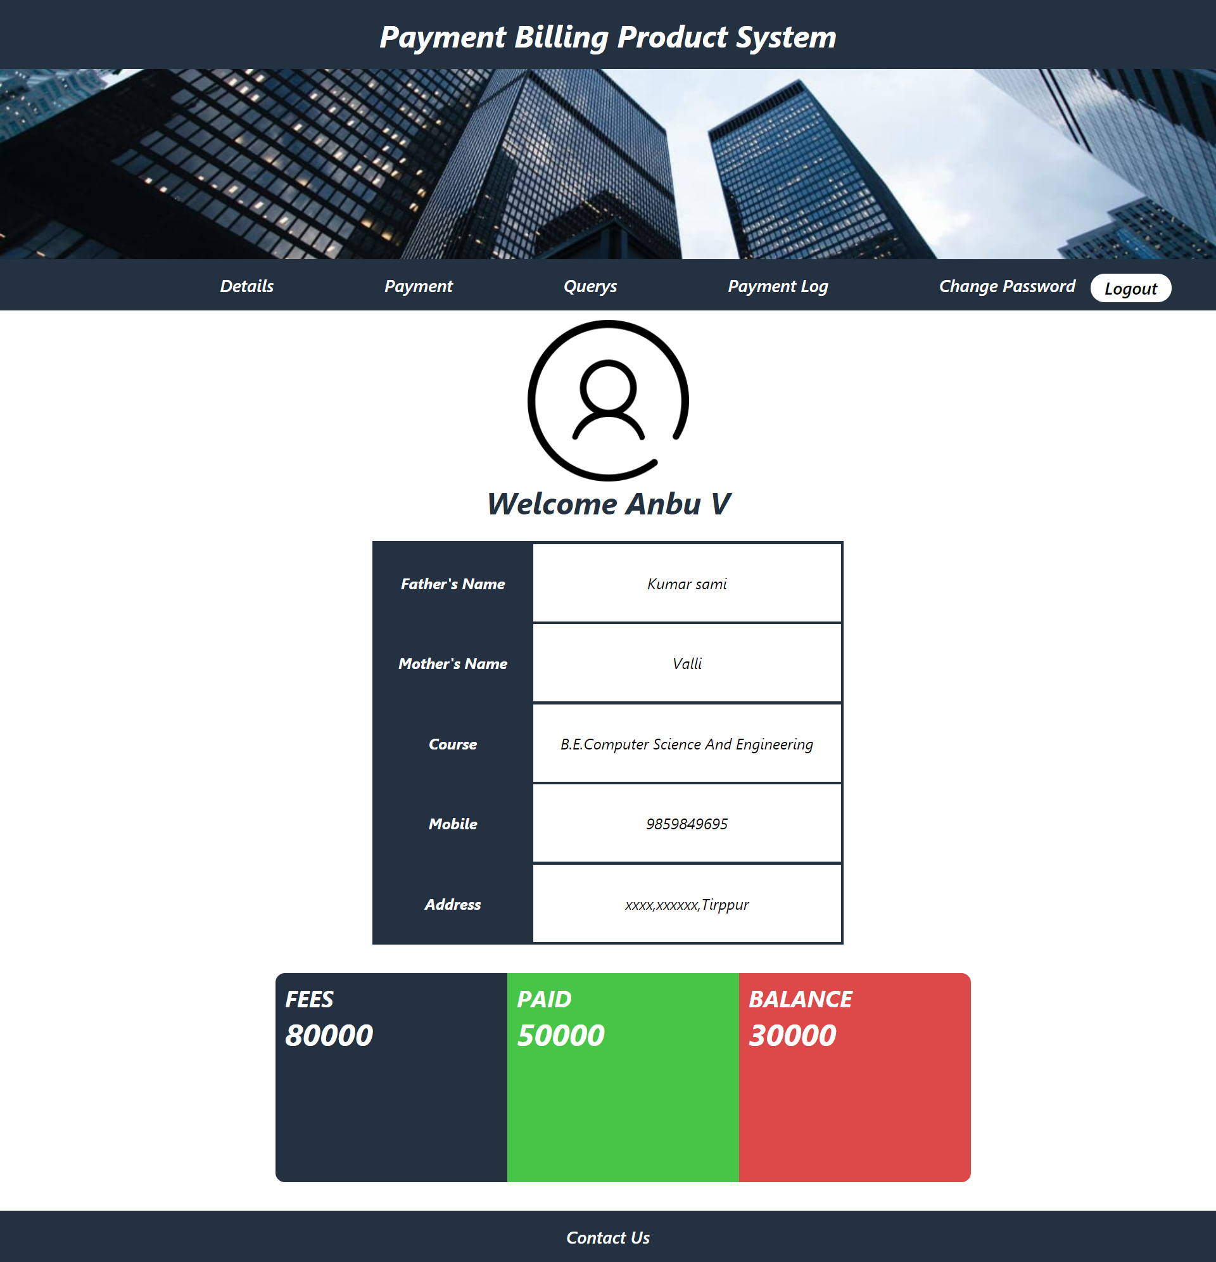

***2.Payment page :***

***In this page the student can pay their fees using online banking or credit or debit card.***

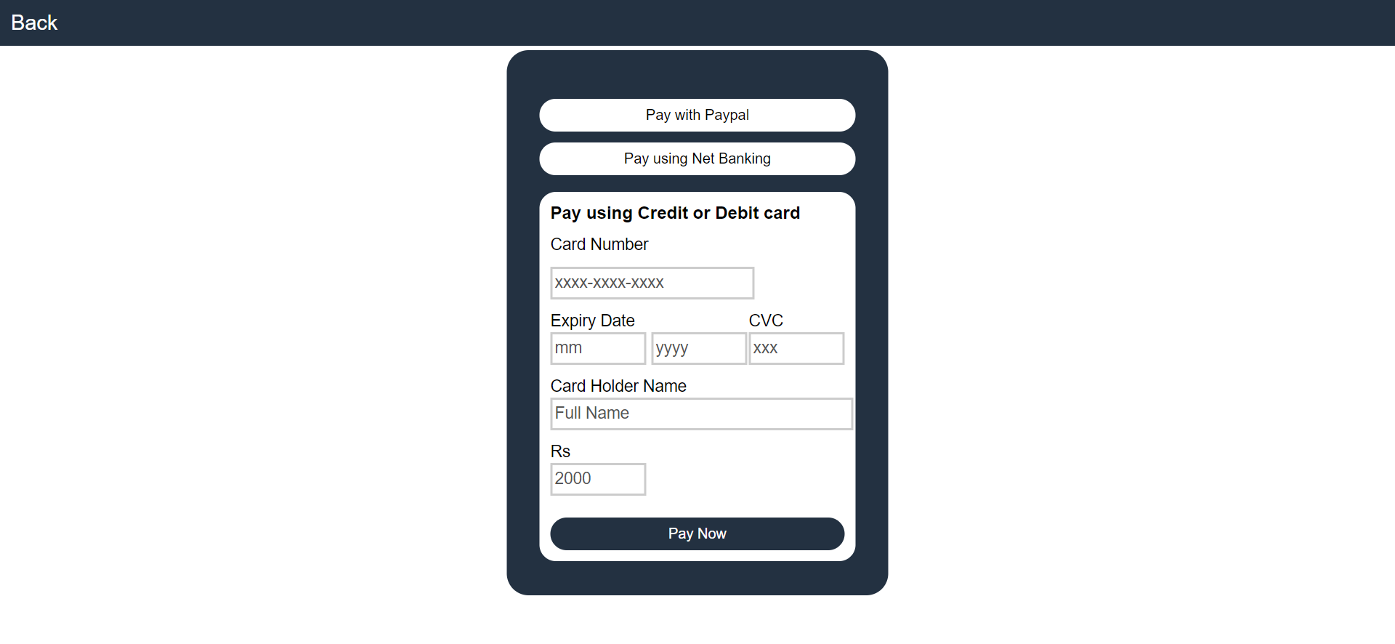

***3.Query page :***

***In this page student’s personal queries can be submitted and it can be viewed by the admin.Once the query has been solved admin can give the mark complete and it will get updated in this page.***

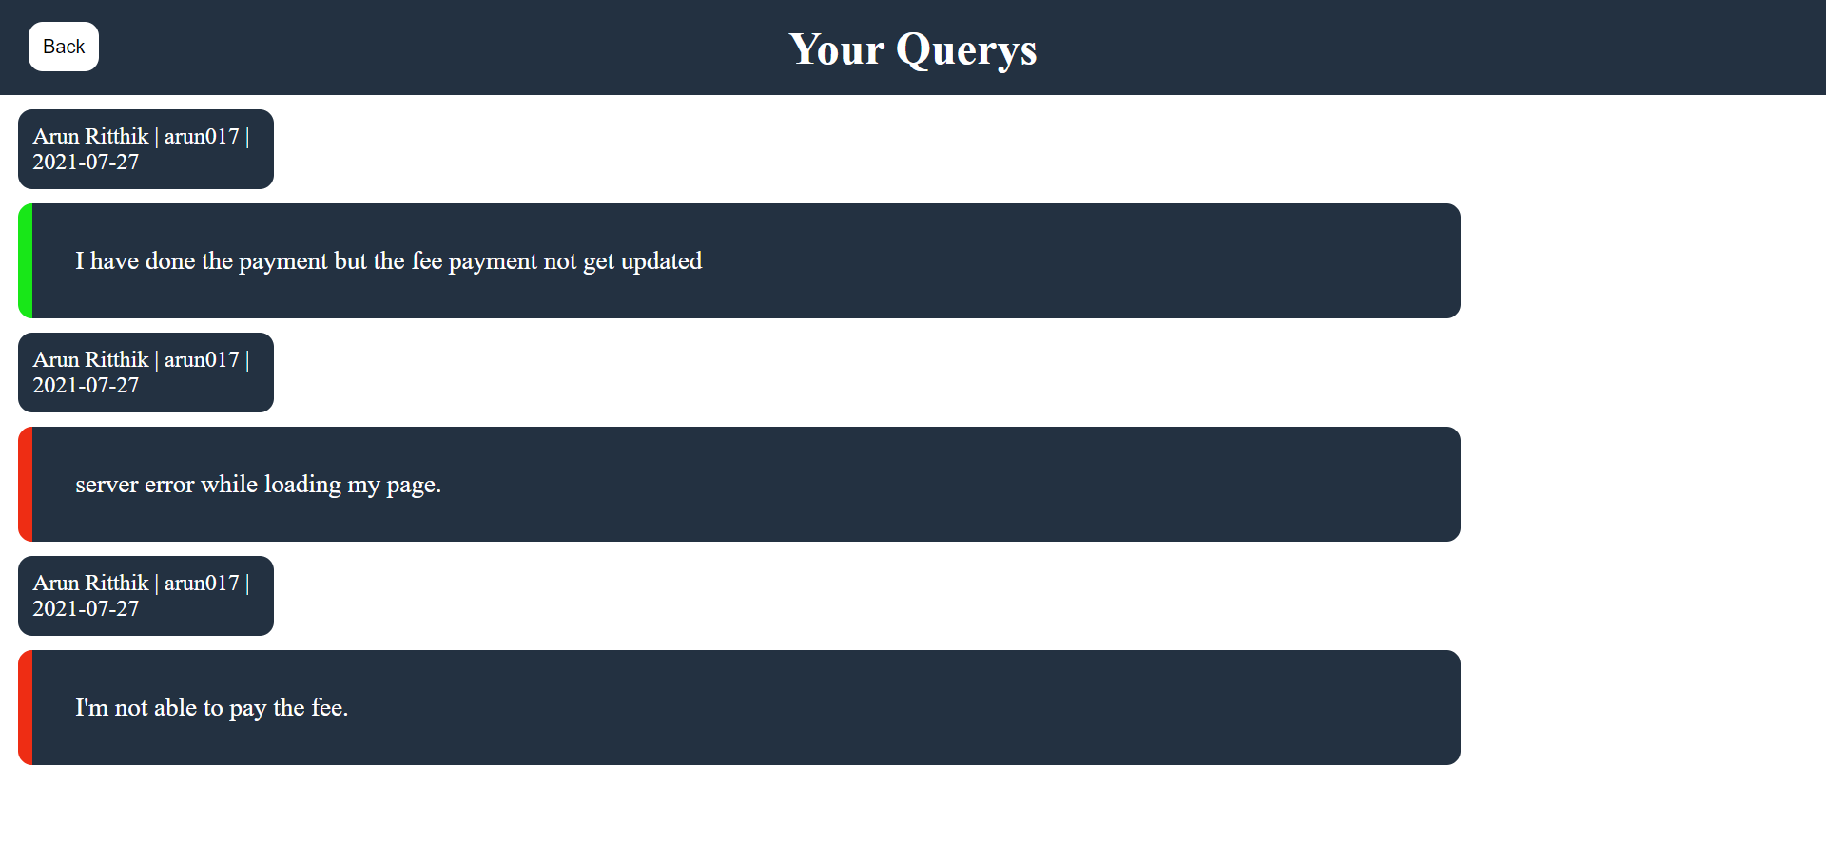

***4.Payment log page :***

***In this page the student can view the details of his/her payment log like when it was paid and how much fee had been paid.***

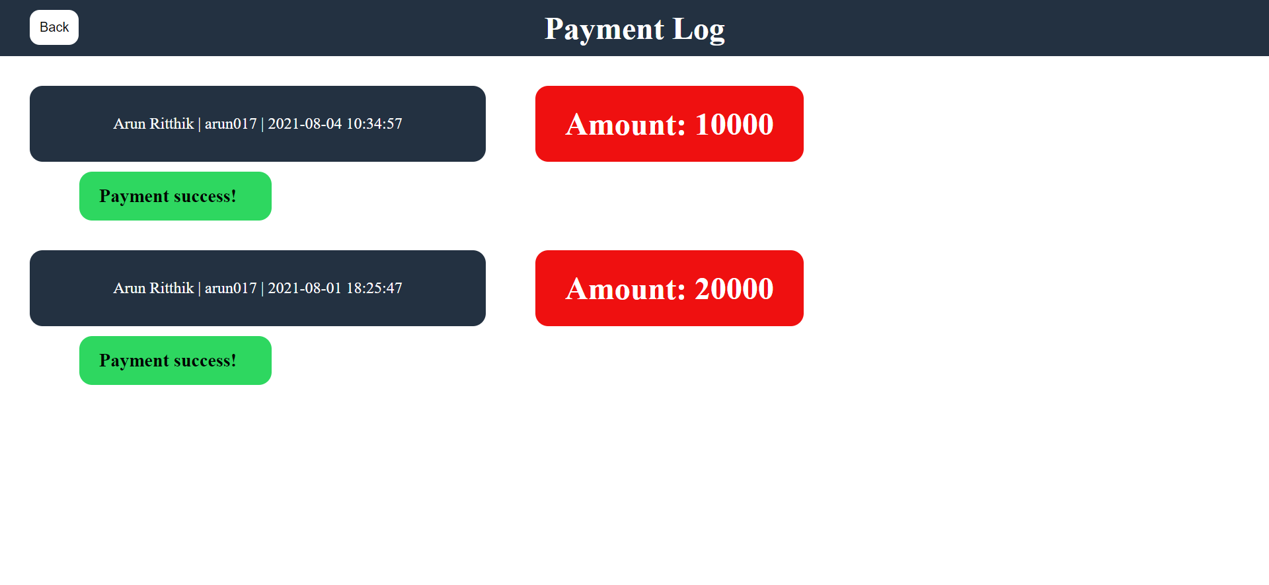

***5.Change password page :***

***In this page an accountant can change his/her password if he/she feels insecure.***



***6.Contact Us Page.***

***In this page the students can contact the admin and submit their queries.***

